Jennifer Biller
Social Studies Teacher
Plymouth High School
jbiller@plymouth.k12.wi.us
920-893-6911x1599
jbillersocialstudies.weebly.com

Courses:
Citizenship Area Studies Revolutions and Evolutions
History of Legal Issues Politics in Action

Classroom Expectations:
- Be Respectful
- Come Prepared
- -netbook
- -notebook
- -folder
- -writing utensil
- Be Open-minded

Grading Scale:
A 94 – 100 A- 90-93
B+ 87-89 B 84-86 B- 80-83
C+ 77-79 C 74-76 C- 70-73
D+ 67-69 D 64-66 D- 60-63
F Below 60
We will be using this main page as our guide to learning this semester. The URL for the homepage is at the top of this handout. When you access the main page, just click on your course and you will have access to all of the learning materials used in class.
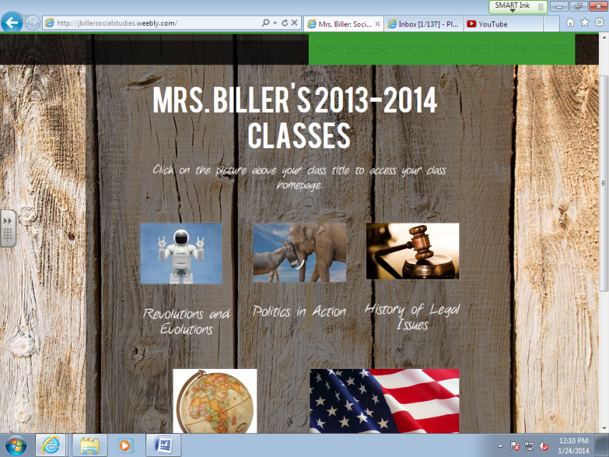 jbillersocialstudies.weebly.com

